
Applied Project Report
Analysis of Real-life Business Cases

By

<Full Name of the Student>

A Master’s Project Report submitted to Scaler Neovarsity - Woolf in partial fulfillment of the requirements for the degree of Master of Science in Computer Science

<Month of Submission like June, 2024>

Scaler Mentee Email ID : <Registered Scaler Email ID>
Thesis Supervisor : Shivank Agarwal
Date of Submission : DD/MM/YYYY <Date of Submission>

Certification

I confirm that I have overseen / reviewed this applied project and, in my judgment, it adheres to the appropriate standards of academic presentation. I believe it satisfactorily meets the criteria, in terms of both quality and breadth, to serve as an applied project report for the attainment of Master of Science in Computer Science degree. This applied project report has been submitted to Woolf and is deemed sufficient to fulfill the prerequisites for the Master of Science in Computer Science degree.

Shivank Agarwal
…………………
Project Guide / Supervisor

DECLARATION

I confirm that this project report, submitted to fulfill the requirements for the Master of Science in Computer Science degree, completed by me from < Course start date > to < Project end date >, is the result of my own individual endeavor. The Project has been made on my own under the guidance of my supervisor with proper acknowledgement and without plagiarism. Any contributions from external sources or individuals, including the use of AI tools, are appropriately acknowledged through citation. By making this declaration, I acknowledge that any violation of this statement constitutes academic misconduct. I understand that such misconduct may lead to expulsion from the program and/or disqualification from receiving the degree.

<Full Name of the Candidate>

<Signature of the Candidate> Date: XX Month 20XX

ACKNOWLEDGMENT

<Insert a Paragraph within this Page to express gratitude to your family, Scaler instructors and everyone who helped, inspired or motivated you to complete the program and earn the Master’s degree>

Table of Contents

List of Tables 6
List of Figures 7
Applied Real-life Business Cases 8
ABSTRACT 8
Chapter 1 : Business Case Study 1 8
Problem Description 8
Business Questions to be answered from Analysis 8
Analysis 9
Insights and Recommendations 10
Chapter 2 : Business Case Study 2 10
Chapter 3 : Business Case Study 3 10
Chapter 4 : Business Case Study 4 10
Chapter 5 : Business Case Study 5 10
CONCLUSION 11
References 12

List of Tables
(To be written sequentially as they appear in the text)

Table No. | Title | Page No.
1
2

List of Figures
(List of Images, Graphs, Charts sequentially as they appear in the text)

Figure No. | Title | Page No.
1
2

Applied Real-life Business Cases

ABSTRACT

The abstract for an applied project should succinctly summarize its title, purpose, methods, results, and conclusions. You are expected to write a chapter on any 5 of the Business Cases which you have completed as part of your DSML course.
NOTE - To ensure confidentiality, do not refer to actual company names. For example, to refer to “Target”, say, “Retailer”, to refer to “Netflix”, say, “Streaming Services Provider”, or simply ‘Company A’ etc…
Since it is going to be a group of five Business Case Studies, the focus should be how DSML and its associated tools as a field of study can be beneficial to the field of business or how such tools can be applied to maximize profit or modify existing processes for better outcomes.
Aim for conciseness, usually limiting it to under 250-300 words, to effectively convey the project's essence.

Chapter 1 : Business Case Study 1

Problem Description
Include the problem statement of the Business Case without directly mentioning the names of companies. For example, to refer to “Target”, say, “Retailer”, to refer to “Netflix”, say, “Streaming Services Provider” or simply ‘Company A’ etc…

Research and Include a background of the business goals of the ‘company’

Include the data table images / figures which are given in the case study question

Business Questions to be answered from Analysis
Include the questions for which you need to find answers in the Case Study

Provide background and Underscore the Significance:
Explain why these questions are important for the companies in this domain / industry

Explain the ‘methodology’ or approach you will use to solve this case study and what are their applications in real-life

Analysis

Provide a detailed step-by-step snapshot / figures / charts / graphs / tables of your analysis run on Jupyter Notebook or Google Colab etc…

Provide commentary on the approach and the step-by-step results along with proper headings to each figure / chart / table

Use the below format as reference when including a table

Table 1.1: < Table caption > (Table captions go above tables.)

Use the below format as reference when including a picture

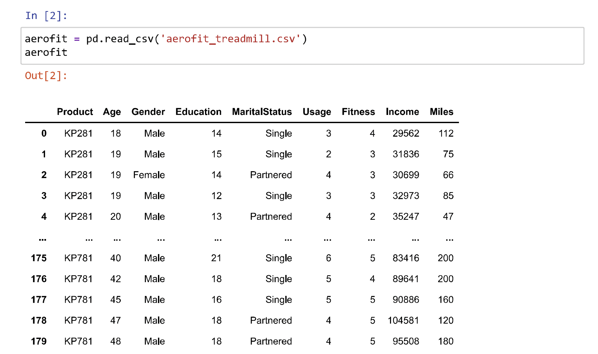
Figure 1.1: Fitness Customer Data (Figure captions go below figures.)

Without the tables, graphs or charts which contribute to the analysis it will appear as incomplete and thereby invite non-compliance.

Insights and Recommendations

Present your results and recommendations for the business case study along with Justification

Discuss Implications : Explore the implications of the results for the Industry / Business / Policy

Address Limitations : Acknowledge any limitations or constraints of the study that may have impacted the results

Provide an alternative explanation or recommendation (if applicable)

Summarize the key learnings, methodology followed / tools used and its applications for the industry

Chapter 2 : Business Case Study 2
<Follow the same structure as for Case Study 1>

Chapter 3 : Business Case Study 3
<Follow the same structure as for Case Study 1>

Chapter 4 : Business Case Study 4

<Follow the same structure as for Case Study 1>

Chapter 5 : Business Case Study 5

<Follow the same structure as for Case Study 1>

NOTE - You can add more business cases as new chapters if you need. Minimum 5 business case studies are required.

CONCLUSION

The Conclusion should include some key points as elaborated below -

- Key Takeaways: Highlight the most important points or lessons learned from the
Project
- Practical Applications : Significance of methodologies / tools with their real-world applications
- Limitations : Limitations of the methodologies / approaches / tools and suggestions for improvement

References

Include the websites or works or the list of works referred to in a text or consulted by you for writing this report

- Name of the Website, Date and time of referring to the Website, Name of the Author, Title/Topic
- Author Name, Title / Topic, Research Paper Name / Book Name, Year of Publication

Format Guidelines

- Detailed and Elaborate report of 100 pages at least is expected
- Margins - Every page of your document must meet the margin requirements of 1.25 inches on the left and right, and 1 inch on the top and bottom.
- Font:
  - Style: Times New Roman,
  - Font Size:14 (For Headings), 12 (For body text) in black colored text.
  - All text must be the same justification, like left justified or fully justified.
- Line Spacing:
  - Body of the text: 1.5
  - List of Tables/graphs/charts/bibliography: single line.
- Alignment:
  - Title page: Centre
  - Chapter Heading: Centre
  - Subheading: Left
  - Body of the text: Justify
- Titles: All titles and subtitles should be in bold. All tables/graphs/charts/figures should have appropriate titles.
- Numbering of the tables, charts, graphs should be in the following fashion: Second table/graph/chart in the second chapter should be numbered as Table/graph/chart no. 2.02; where the first digit stands for chapter no. and digits after (.) stands for number of table/graph/charts in that chapter. Same numbering should be followed for all other chapters.

